- 3) Setup a Jenkins CICD pipeline using Scripted pipeline using feature-1.1 branch.
Source Code: https://github.com/betawins/sabear_simplecutomerapp/tree/feature-1.1
stages:
- Git Clone
- SonarQube Integration
- Maven Compilation
- Nexus Artifactory
- Deploy On tomcat

Creating a new job
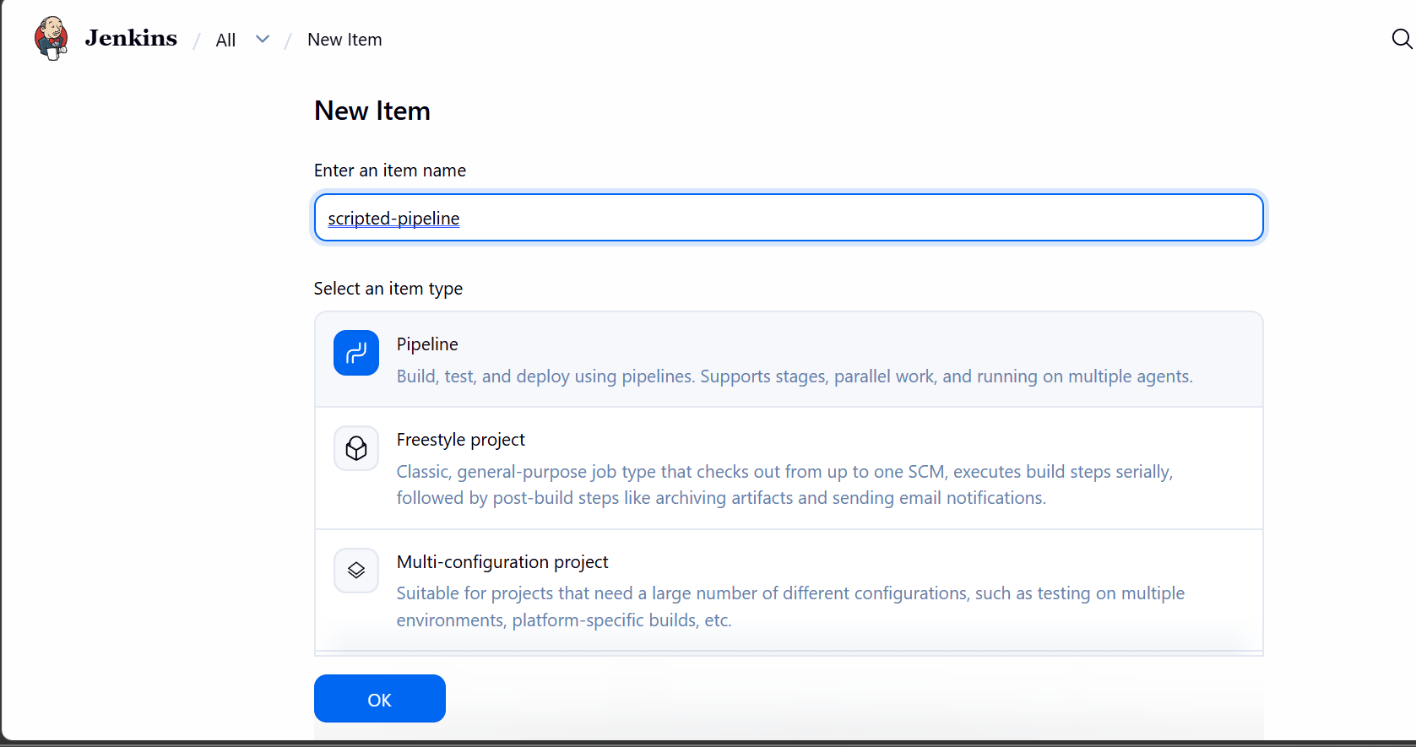

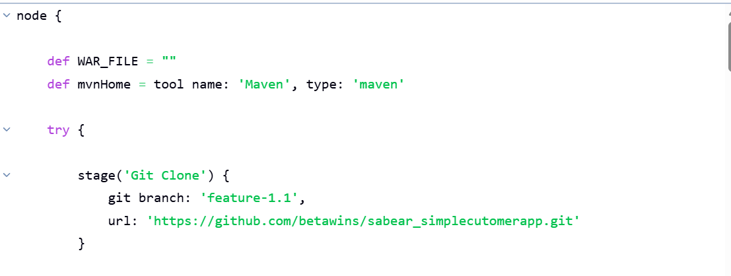
Cloning the repo
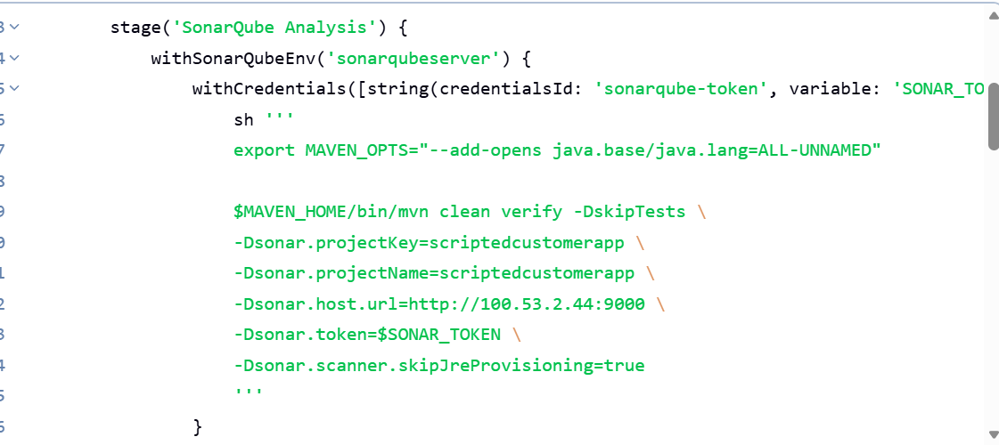

Sonarqube analysis
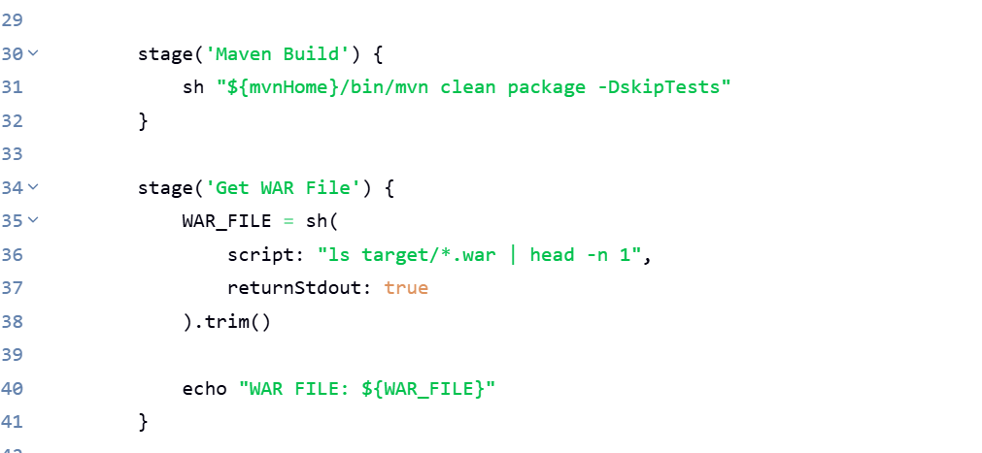
Building the code

Maven build
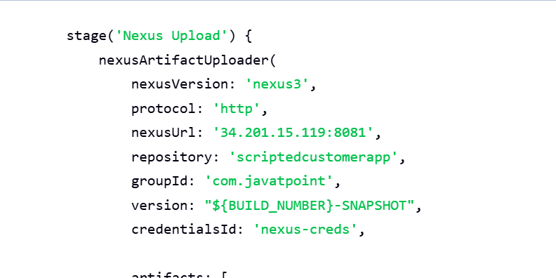
uploading the artifact to nexus
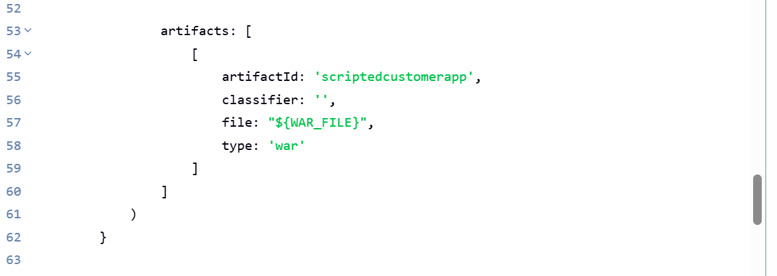

Tomcat deployment
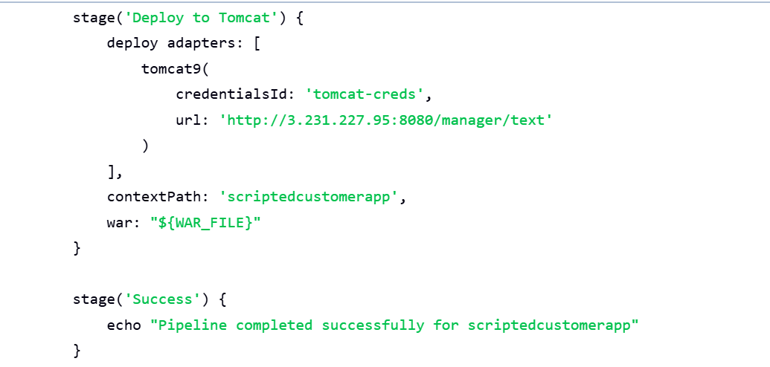

Artifact uploaded to nexus repo scriptedcustomerapp
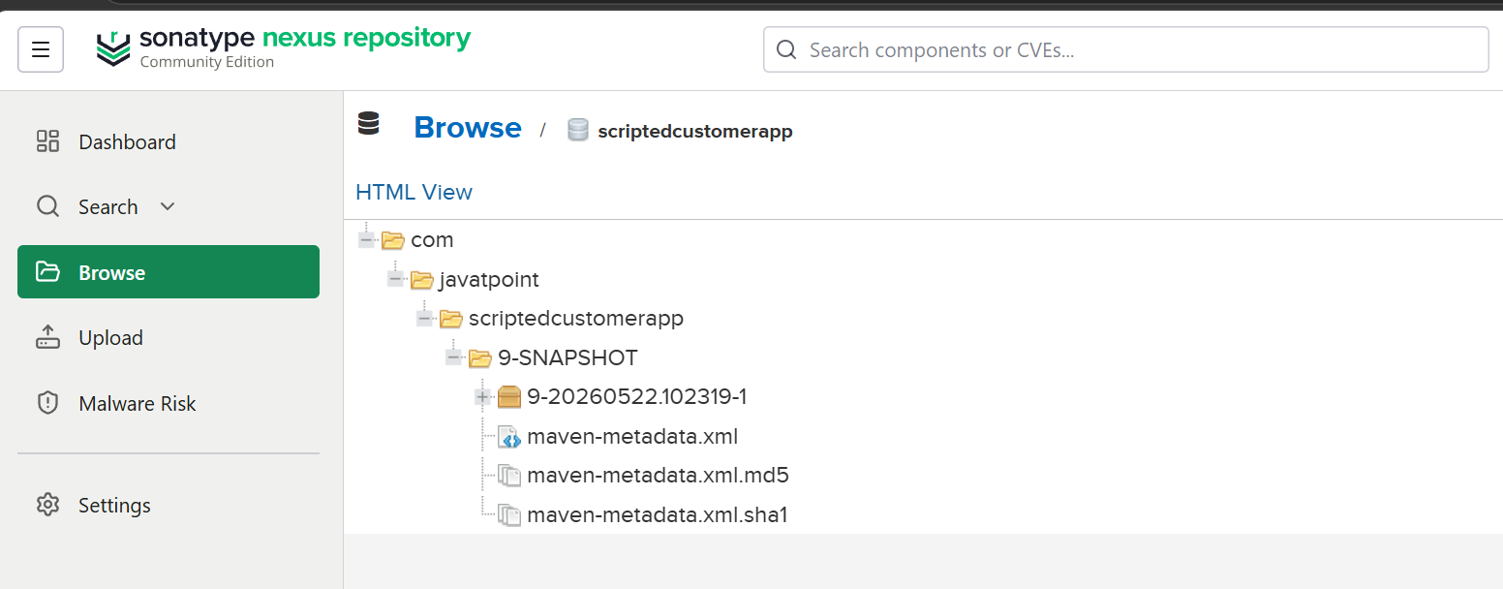

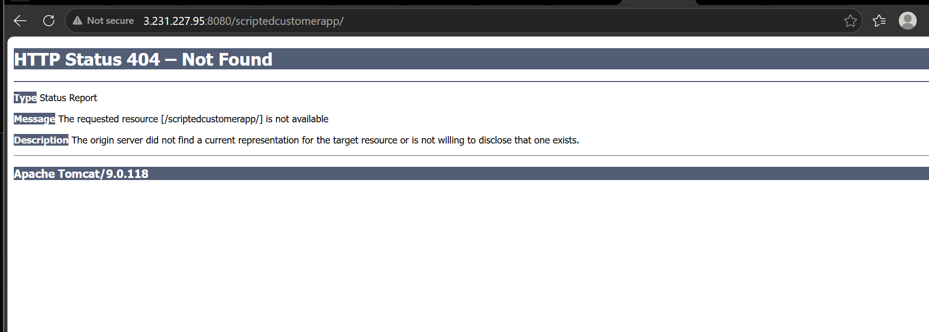

4) Write sample skeleton of pipelines.

pipeline {
agent any

tools {
maven 'Maven'
}

stages {

stage('Git Clone') {
steps {
git branch: 'feature-1.1',
url: 'https://github.com/betawins/sabear_simplecutomerapp.git'
}
}

stage('SonarQube Integration') {
steps {
echo 'SonarQube analysis will run here'
}
}

stage('Maven Build') {
steps {
sh 'mvn clean package'
}
}

stage('Nexus Upload') {
steps {
echo 'Artifact upload to Nexus will happen here'
}
}

stage('Deploy to Tomcat') {
steps {
echo 'WAR deployment to Tomcat will happen here'
}
}
}
}

5) Create a parameterized job in Jenkins.

Go to Jenkins
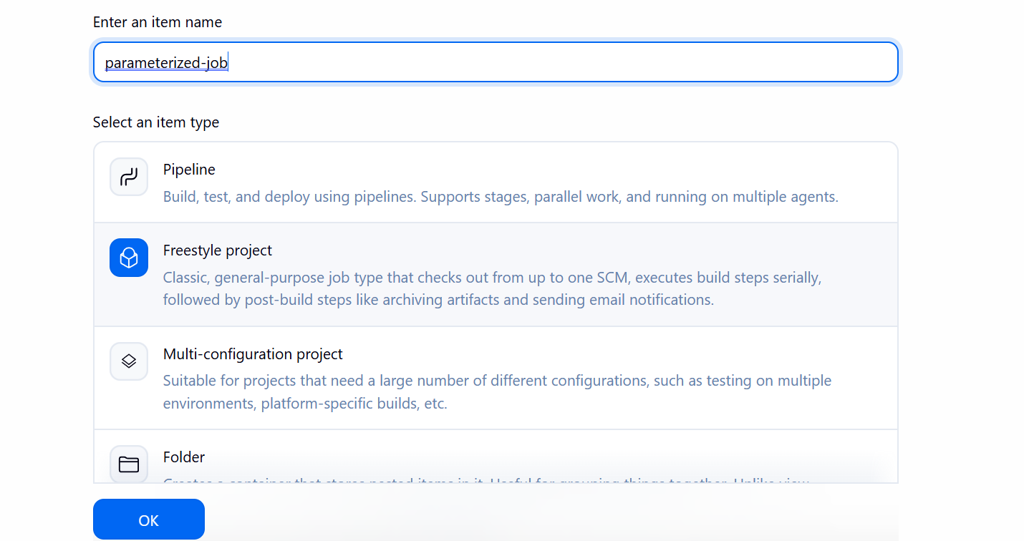
Go to all and create new item

Under configure select this is parameterized job
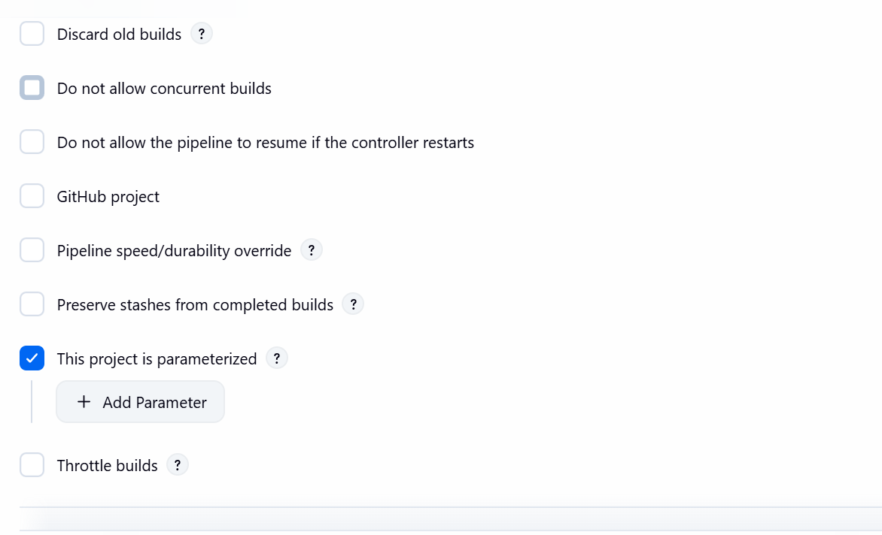
String parameter:
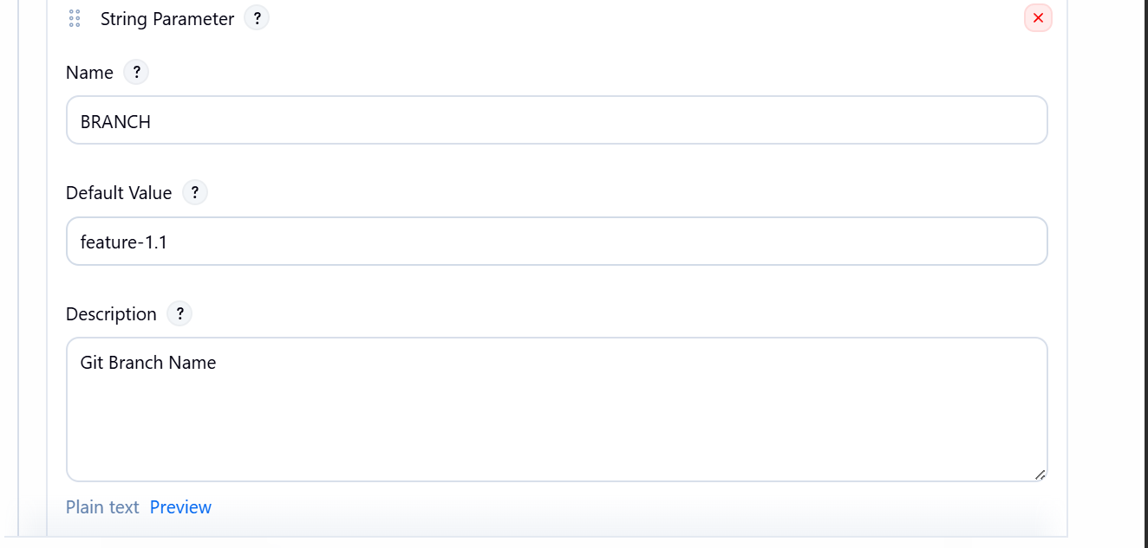

Choice parameter:

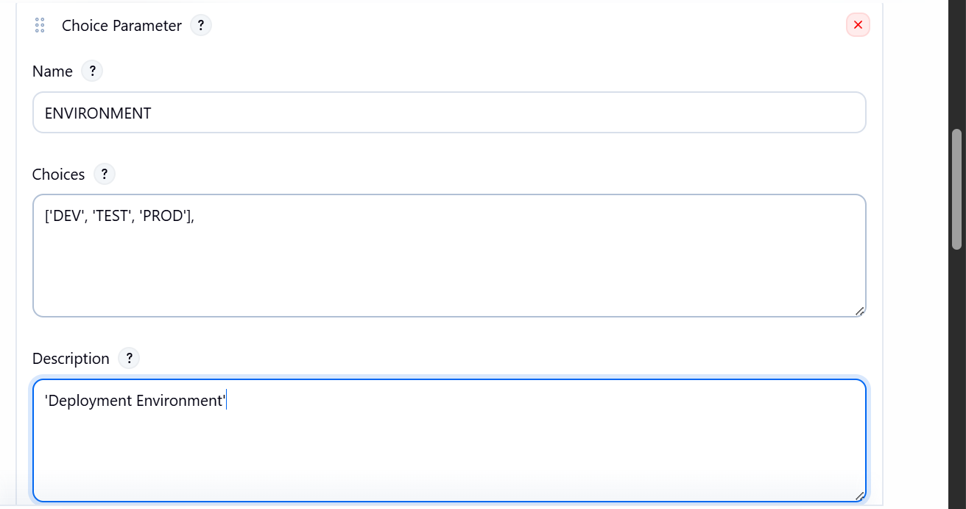

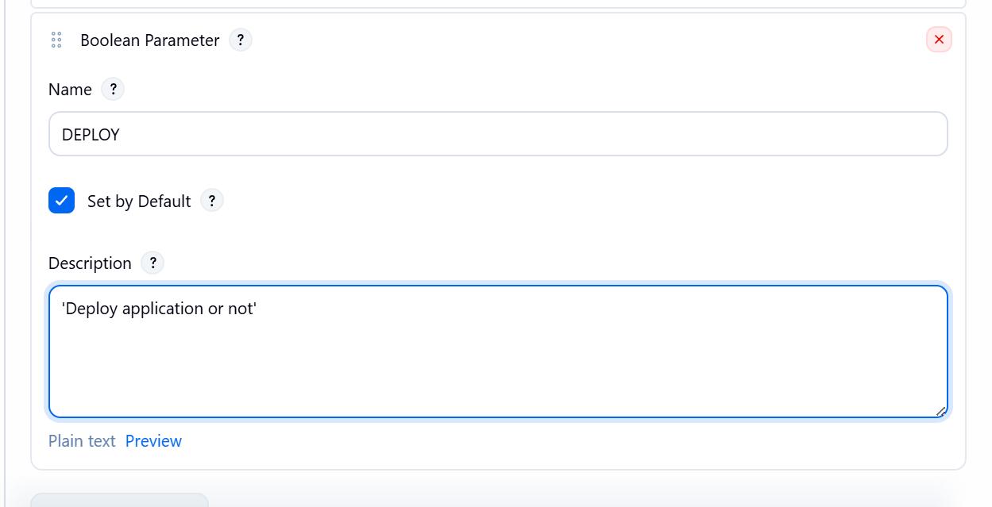

Using branch parameter
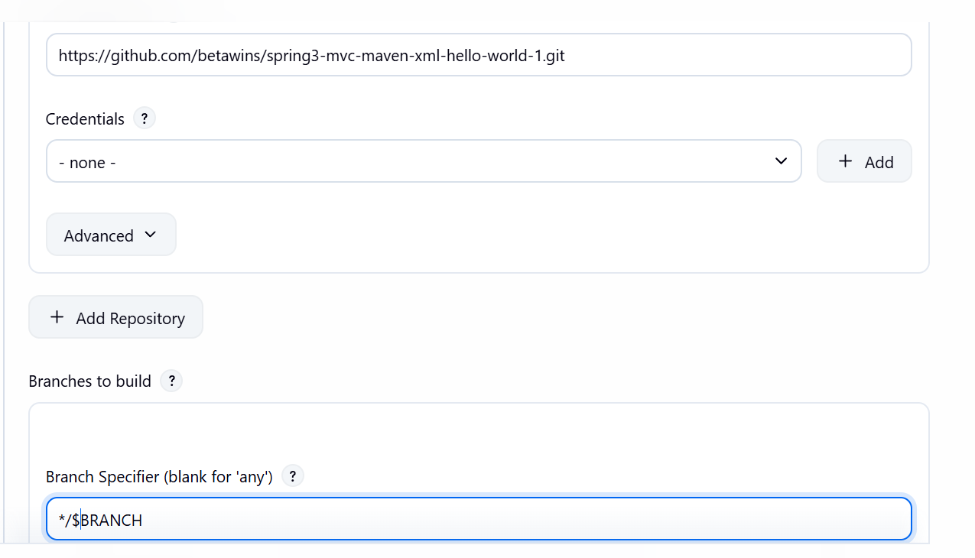

Build version parameter

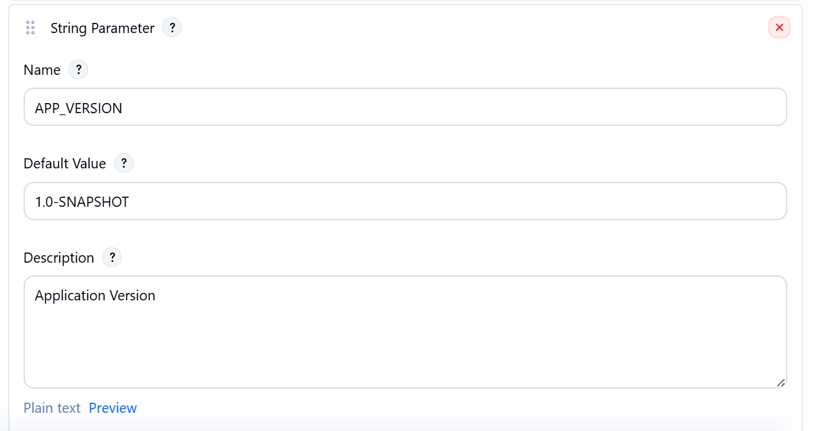

Building with parameters
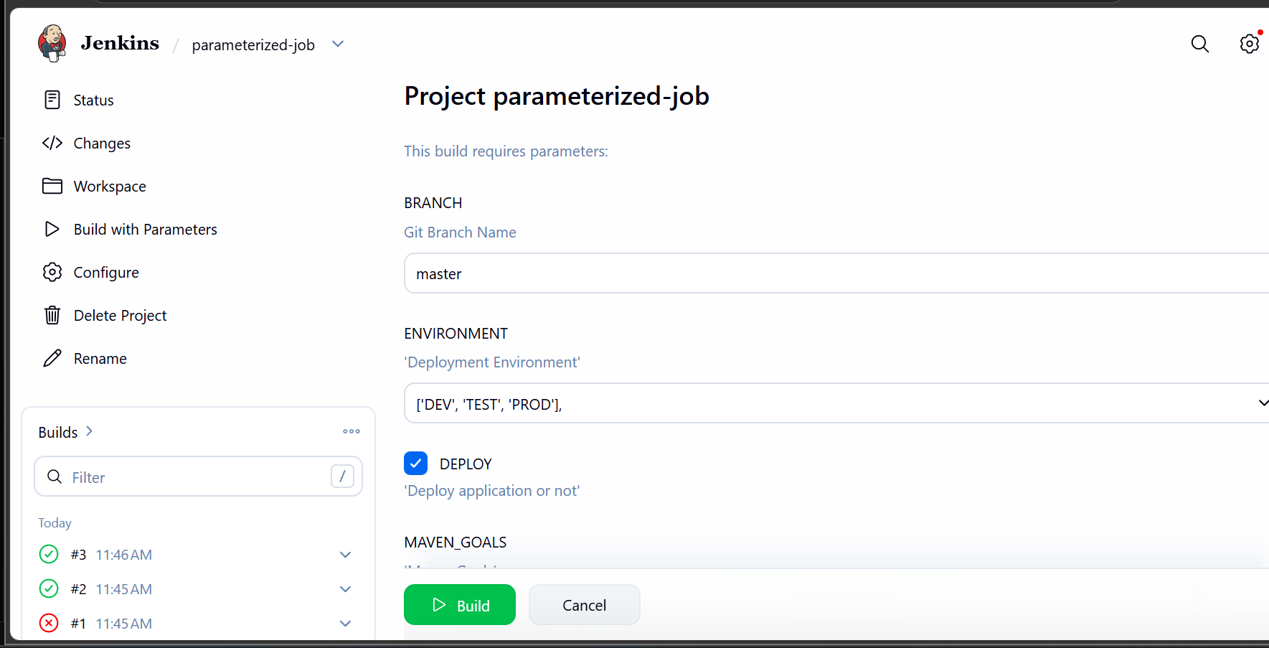

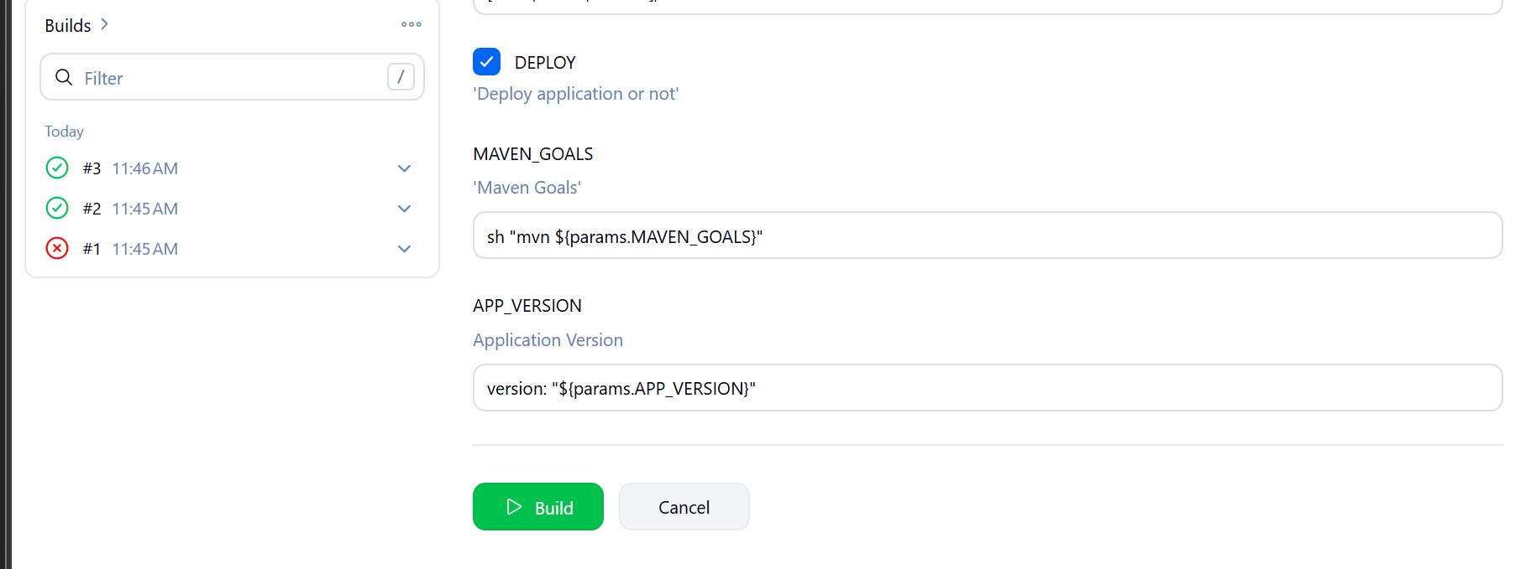
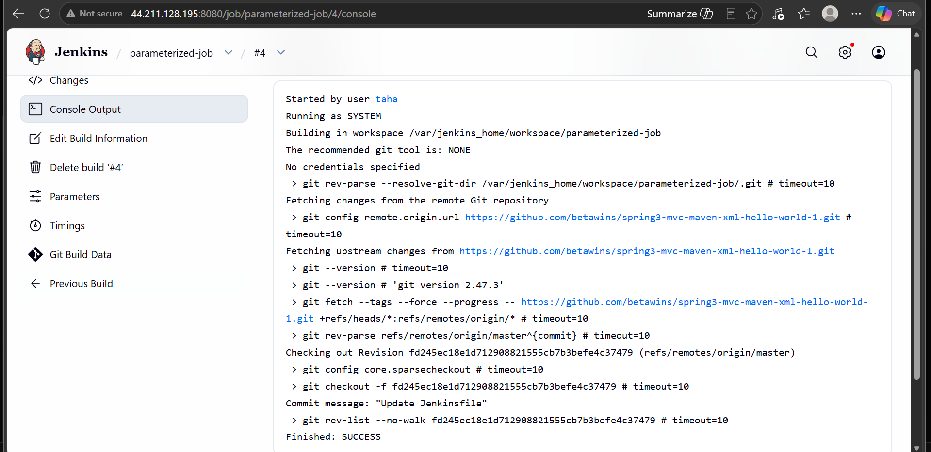

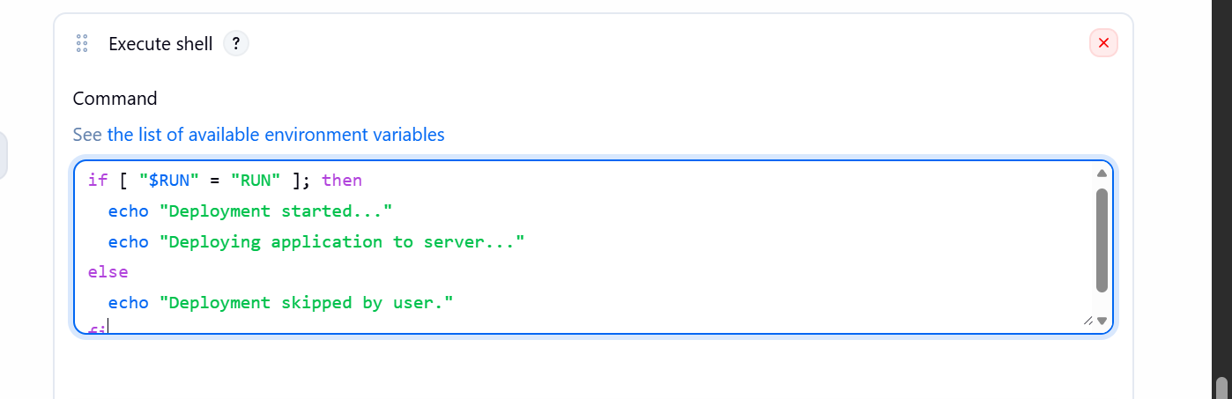
Adding shell command in build section

Job ran successfully

6) Setup one slave machine for Jenkins
Now lets launch one more instance
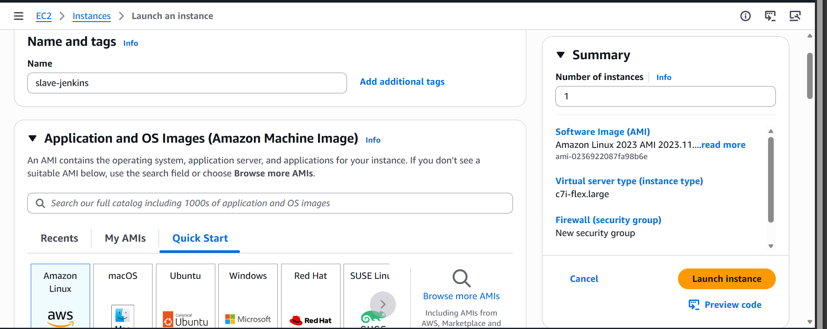
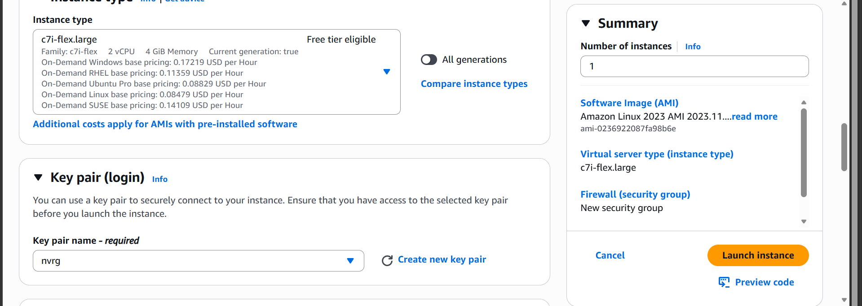
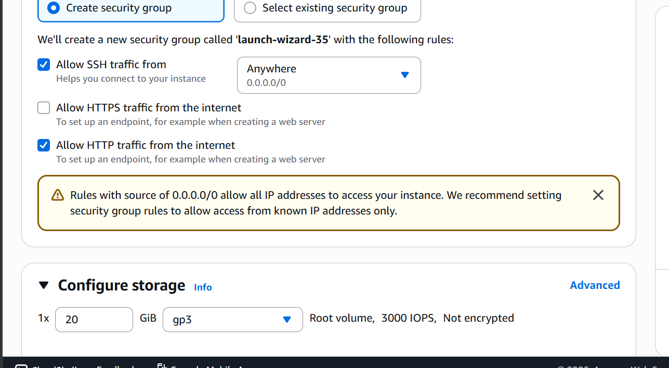
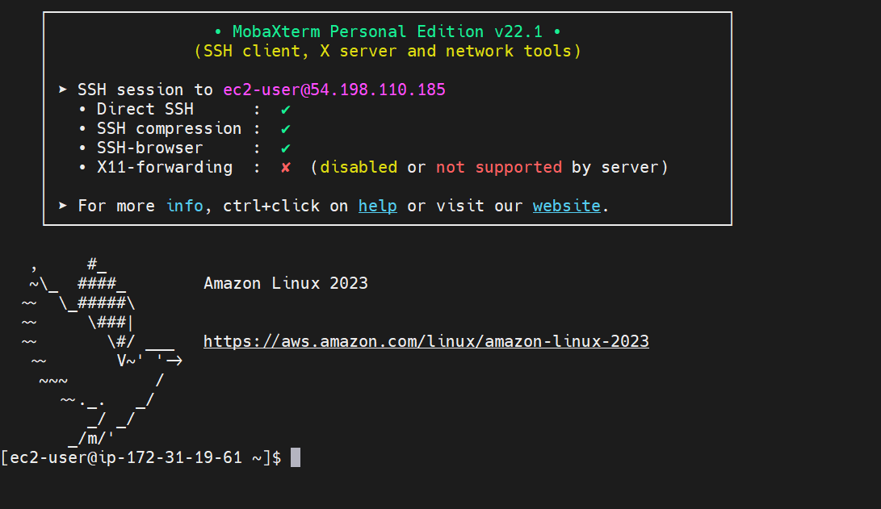

Ssh into the slave machine
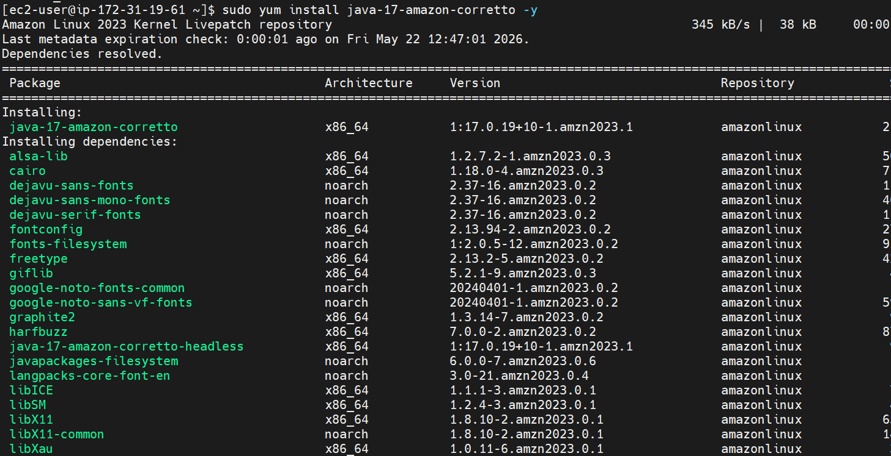
Installing java
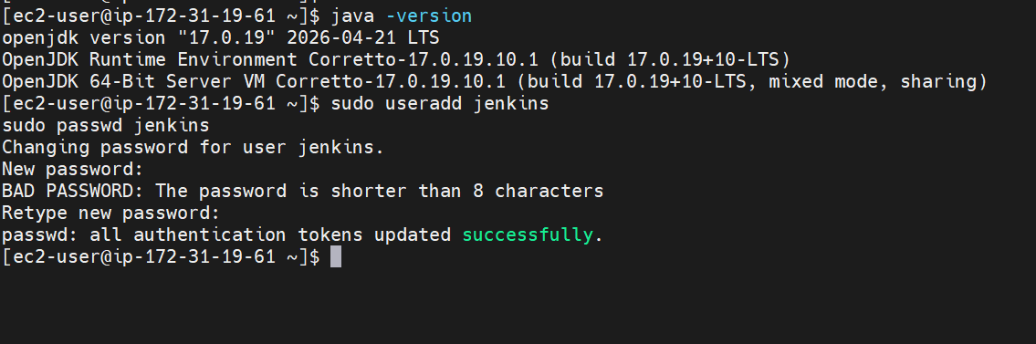
Now login to Jenkins master
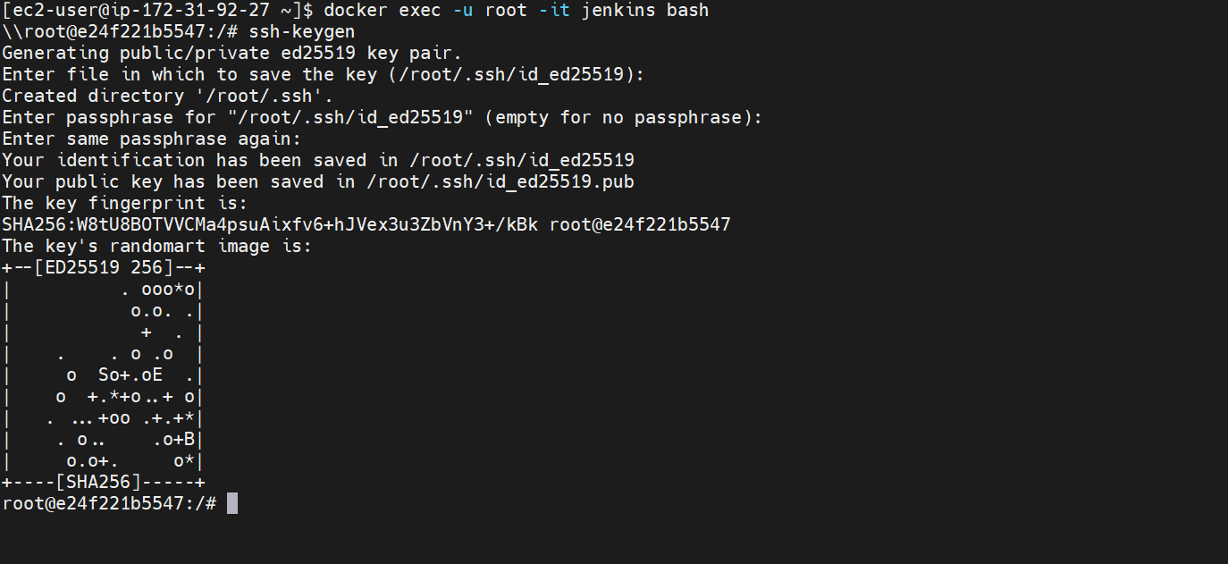
Generate ssh key inside the container
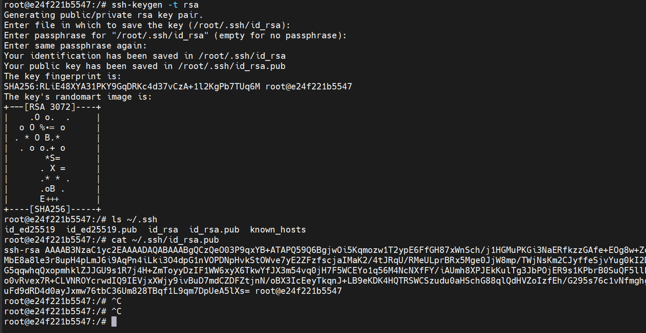

And now paste in the authorized_keys directory of slave

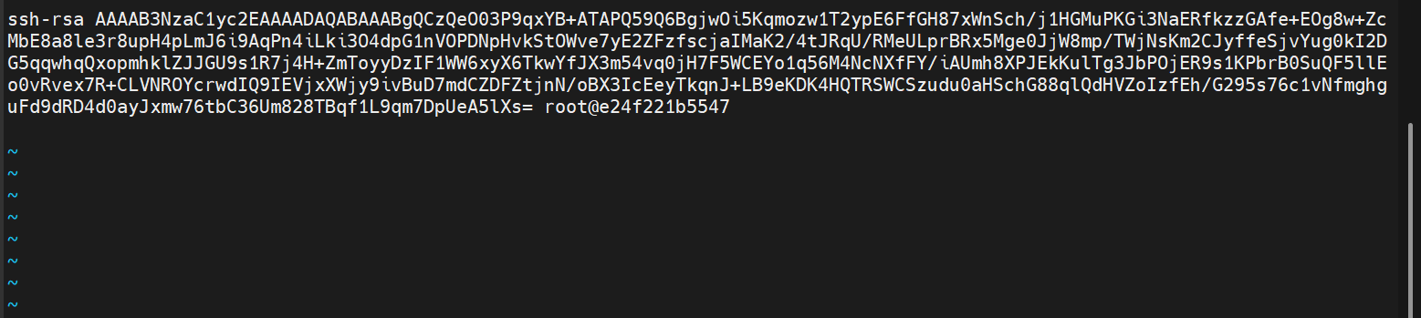

Change the permissions

